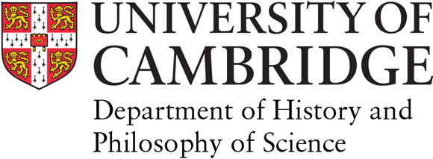
Research and Collaboration Awards on the Histories of AI:

A Genealogy of Power Sawyer Seminar

APPLICATION FORM

Deadline for Applications: 14 February 2020
Summary: Four awards of up to £2000 to support research and engagement with Seminar themes, open to international participants across the diverse communities engaged with AI.

APPLICATION INSTRUCTIONS:
Save this document as RA-surname-firstname.doc(x) and email it as an attachment to hoai@hermes.cam.ac.uk to arrive no later than midnight GMT on 14 February 2020. (Note: The boxes will expand as you type or paste in content.)

OVERVIEW:
The University of Cambridge is hosting a Mellon Sawyer Seminar entitled Histories of AI: A Genealogy of Power from May 2020-April 2021. The Seminar will be co-hosted by the Department of History and Philosophy of Science, and the Faculty of English. Sawyer Seminars support comparative research on the historical and cultural sources of contemporary developments. This Seminar aims to develop an international interpretive community capable of offering a structural, historical perspective on the promises and problematics of AI and machine learning.

This new community will include participants from a variety of fields and backgrounds including activists, AI practitioners, artists, citizens, critical theorists, decolonial scholars, historians of science and technology, and scholars from race, gender, and disability studies. We will engage in critical and comparative research, from antiquity to the present, on the historical and cultural sources of contemporary developments in AI technologies to investigate their entanglement in systems of politics, power and control. Four themes will guide our considerations: hidden labour, encoded behaviour, cognitive injustice and disingenuous rhetoric.

The Seminars activities include:
• A weeklong Summer School, hosted at the University of Cambridge from 12-18 July 2020;
• A monthly Reading Group, hosted at the University of Cambridge but accessible online for international participants;
• A one-day Graduate Winter School, hosted at the University of Pennsylvania
• Four Public Events in Spring 2021 on the Seminar themes, held in Cambridge, London, and at Columbia University
• A concluding Symposium for core Seminar members, held at the University of Cambridge in April 2021

We are inviting applications to the Seminar’s Research and Collaboration Awards, of up to £2000 per applicant. These are intended to support research and other forms of engagement with the Seminar’s themes and aims. We are particularly interested in supporting research activities located in Asia and the Global South. It is intended that these Awards extend the Seminar’s community beyond its Anglo-American-situated core participants and support work and reflection across the diverse communities engaging with AI.

Successful Research and Collaboration Award recipients will be:
• expected to participate in Seminar activities, in particular the Summer and/or Winter Schools, including presenting their work;
• invited to contribute to Seminar outputs;
• supported in their research and other activities through engagement with the Seminar.

To apply for a Research and Collaboration Award on the Histories of AI: A Genealogy of Power Sawyer Seminar, please complete this application form.

1. SURNAME (family name) 2. OTHER NAMES 3. TITLE

4. EMAIL

5. 500-800 word research or activity proposal, including explanation of fit with the Seminar's aims.

6. PLEASE ATTACH A Budget (to a maximum of £2000). For instance, you may wish to support archival research, interviews, or travel to seminar events. Figures can be indicative.

7. PLEASE ATTACH A Sample of work. For example, a thesis chapter, art piece or other piece of writing. This can be in draft form.

8. PLEASE ATTACH A CV.

We are committed to protecting your personal information and being transparent about what information we hold. Please consult Data Protection Policy for further information.

